SECOND ASSIGNMENT REPORT
Lagrangian and Hamiltonian Mechanics



Name : Jeremia Christ Immanuel Manalu
NRP : 5023231017
Course : Biocybernetics
Class : Q
Lecturer : Dr. Achmad Arifin, S.T., M.Eng.
Department : Biomedical Engineering

FACULTY OF INTELLIGENT ELECTRICAL AND INFORMATICS TECHNOLOGY
INSTITUT TEKNOLOGI SEPULUH NOPEMBER
2026

CHAPTER I. FUNDAMENTAL THEORY

1.1 Lagrangian and Hamilton’s Principle
Lagrangian mechanics describes a system with generalized coordinates $q$ (distances or angles) instead of force vectors. The Lagrange function is the kinetic energy minus the potential energy, Equation (1.1) [1][2]. Hamilton’s principle states that between two fixed instants $t_{1}$ and $t_{2}$ the system follows the path for which the action $S$, the time integral of $L$, is stationary. A small change $δq\left(t\right)$ of the path that keeps both end points fixed does not change $S$ to first order, as written in Equation (1.2) and shown in Figure 1.1 [2][3].
$$L=T-V \left(1.1\right)$$
$$S=\int_{t_{1}}^{t_{2}}{L}\left(q,\dot{q},t\right)dt, δS=0 \text{with} δq\left(t_{1}\right)=δq\left(t_{2}\right)=0 \left(1.2\right)$$
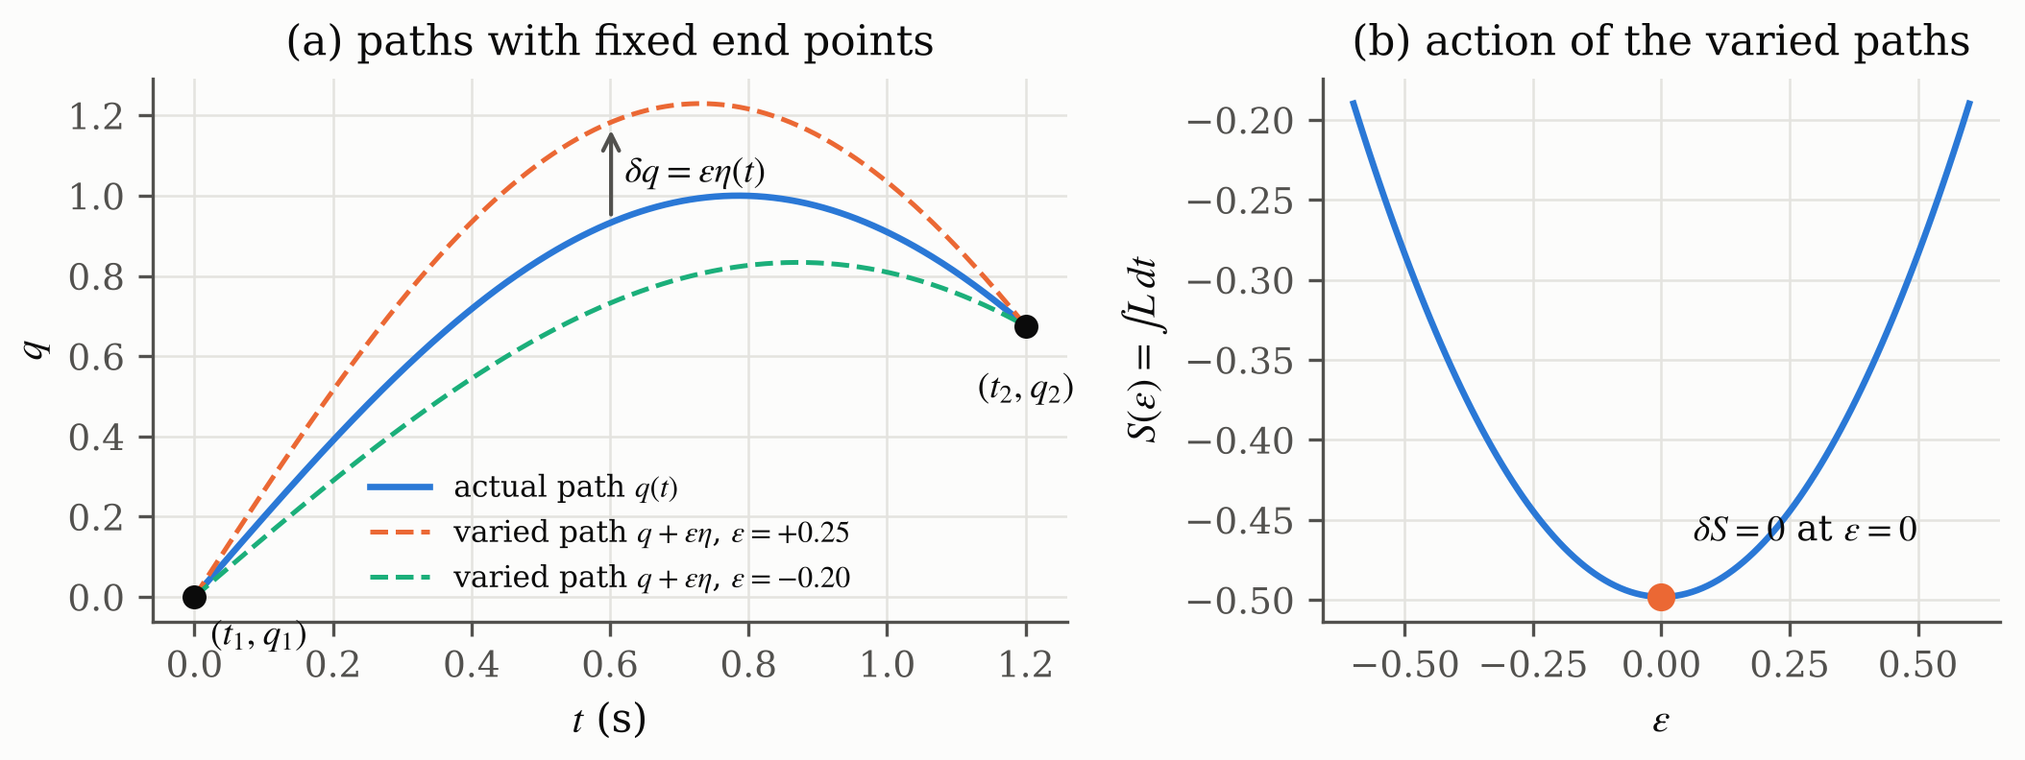
Figure 1.1. Hamilton’s principle, with (a) the actual path and two varied paths with the same end points and (b) the action, which is stationary for the actual path $ϵ=0$

1.2 Euler-Lagrange Equation, Momentum and Force
Hamilton’s principle leads to one Euler-Lagrange equation per coordinate, Equation (1.3), and the proof of this step is the answer to Problem 1. An external (non-conservative) force or torque $τ$, for example a muscle torque, appears on the right-hand side, which is the motion equation of the lecture [1]. The derivative of $L$ with respect to a velocity is the generalized momentum, Equation (1.4). The lecture shows the simplest case $L=1/2m{\dot{x}}^{2}-V\left(x\right)$, where $p=m\dot{x}$ and Equation (1.3) becomes Newton’s law $m\ddot{x}=-∂V/∂x$ [1]. If a coordinate does not appear in $L$, its momentum is constant.
$$\frac{d}{dt}\frac{∂L}{∂\dot{q}}-\frac{∂L}{∂q}=τ \left(τ=0 \text{without external force}\right) \left(1.3\right)$$
$$p=\frac{∂L}{∂\dot{q}} \left(1.4\right)$$

1.3 Hamiltonian Mechanics
The Hamiltonian replaces the velocity by the momentum, Equation (1.5). For a pendulum it is the total energy $T+V$ and it stays constant [1]. Strictly, this holds because the link does not change with time and $L$ does not contain $t$ explicitly [2]. Hamilton’s equations, Equation (1.6), are first-order equations in position and momentum. Table 1.1 summarizes the comparison given in the lecture.
$$H=∑p \dot{q}-L=T+V \left(1.5\right)$$
$$\dot{q}=\frac{∂H}{∂p}, \dot{p}=-\frac{∂H}{∂q} \left(1.6\right)$$
Table 1.1. Lagrangian and Hamiltonian mechanics (after the lecture [1])
 | Lagrangian mechanics | Hamiltonian mechanics
Function | $$L=T-V$$ | $$H=T+V$$
Variables | position and velocity | position and momentum
Equations | one second-order equation per coordinate | two first-order equations per coordinate
Conserved | $L$ is not constant | $H$ is constant

1.4 Coordinates of the Pendulum
Problem 2 uses the coordinates of the assignment figure, redrawn in Figure 1.2. The pivot is the origin, $z$ points up, $θ$ is measured from the $+z$ axis, $φ$ is the angle in the horizontal $xy$ plane and $ρ$ is the projection of the link on that plane, Equation (1.7) [3]. Because $θ$ is measured from the upward axis, the bob hangs at $θ=π$, and the angle from the downward vertical is $α=π-θ$. The link is rigid, so the distance $r=l$ is constant and only $θ$ and $φ$ can change.
$$x=rsinθcosφ, y=rsinθsinφ, z=rcosθ, ρ=rsinθ \left(1.7\right)$$
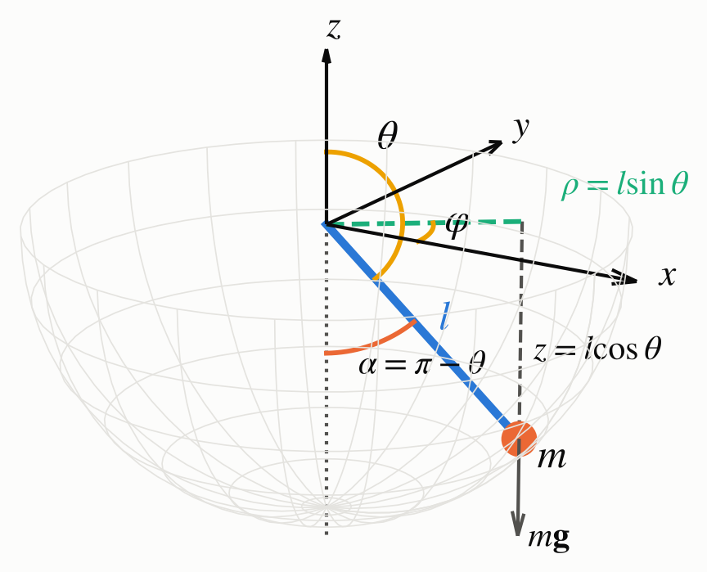
Figure 1.2. Coordinates of the pendulum as in the assignment figure, where $α=π-θ$ is the angle from the downward vertical

1.5 Numerical Integration
The equations of motion give accelerations (Lagrange) or rates of change (Hamilton), not the position itself. The position is obtained by integrating them in time. For the 3D pendulum this has no closed-form solution, so the program uses the fourth-order Runge-Kutta method (RK4) of Assignment 1, Equation (1.8), on a state vector $y$ of first-order equations [4].
$$y_{k+1}=y_{k}+\frac{Δt}{6}\left(K_{1}+2K_{2}+2K_{3}+K_{4}\right) \left(1.8\right)$$
$$K_{1}=f\left(y_{k}\right), K_{2}=f​\left(y_{k}+{Δt}/2K_{1}\right), K_{3}=f​\left(y_{k}+{Δt}/2K_{2}\right), K_{4}=f\left(y_{k}+Δt K_{3}\right)$$

CHAPTER II. RESULT AND ANALYSIS

2.1 Problems Statement
1. Prove of relationship of Hamilton’s principle and Lagrange Equation, with Lagrange function L=T-V, where T is Kinetic Energy, and V is Potential Energy.
a) $\frac{∂L}{∂\dot{θ}}=p$
b) A motion equation $ṗ=F$ can be derived form $\frac{d}{dt}\frac{∂L}{∂\dot{θ}}=\frac{∂L}{∂θ}$
2. For a position vector of a pendulum with a bob at the end of link in 3d coordinate as in this Figure.
- a) Determine expression of Kinetic and Potential Energy. You can use cylindrical polar coordinates 𝜌,𝜑,𝑧 or spherical polar coordinates 𝑟,𝜑,𝑧.
- b) Determine the motion equation based on Lagrangian method to get position and velocity of the motion, and based on Hamiltonian method to get position and momentum.

2.2 Answer and Code Explanation
Each derivation is written as equations only, step by step from the known quantities, and a short explanation follows each block. The final results are highlighted in yellow.

2.2.1 Problem 1 (Hamilton’s Principle and the Lagrange Equation)
The coordinate is written as $q=θ$. The actual path $q\left(t\right)$ between the fixed instants $t_{1}$ and $t_{2}$ is compared with neighbouring paths that start and end at the same points, where $ϵ$ is a small number and $η\left(t\right)$ is any smooth function.
$$\tilde{q}\left(t\right)=q\left(t\right)+ϵ η\left(t\right), \dot{\tilde{q}}\left(t\right)=\dot{q}\left(t\right)+ϵ \dot{η}\left(t\right), η\left(t_{1}\right)=η\left(t_{2}\right)=0 \left(2.1\right)$$
$$\begin{matrix}S\left(ϵ\right)=\int_{t_{1}}^{t_{2}}{L}\left(q+ϵη, \dot{q}+ϵ\dot{η}, t\right)dt \\ L\left(q+ϵη, \dot{q}+ϵ\dot{η}, t\right)=L\left(q,\dot{q},t\right)+ϵ\left(\frac{∂L}{∂q} η+\frac{∂L}{∂\dot{q}} \dot{η}\right)+O\left(ϵ^{2}\right)\end{matrix}$$
$$δS=ϵ{\left.\frac{dS}{dϵ}\right|}_{ϵ=0}=ϵ\int_{t_{1}}^{t_{2}}{\left(\frac{∂L}{∂q} η+\frac{∂L}{∂\dot{q}} \dot{η}\right)}dt \left(2.2\right)$$
$$u=\frac{∂L}{∂\dot{q}}, dv=\dot{η} dt ⇒ du=\frac{d}{dt}​\left(\frac{∂L}{∂\dot{q}}\right)dt, v=η$$
$$\int_{t_{1}}^{t_{2}}{\frac{∂L}{∂\dot{q}}} \dot{η} dt={\left[\frac{∂L}{∂\dot{q}} η\right]}_{t_{1}}^{t_{2}}-\int_{t_{1}}^{t_{2}}{\frac{d}{dt}}​\left(\frac{∂L}{∂\dot{q}}\right)η dt=-\int_{t_{1}}^{t_{2}}{\frac{d}{dt}}​\left(\frac{∂L}{∂\dot{q}}\right)η dt \left(2.3\right)$$
$$δS=ϵ\int_{t_{1}}^{t_{2}}{E}\left(t\right) η\left(t\right) dt, E\left(t\right)≡\frac{∂L}{∂q}-\frac{d}{dt}\frac{∂L}{∂\dot{q}}$$
$$\begin{matrix}\left(⇒\right) δS=0 ∀η. \text{Assume }E\left(t^{*}\right)>0 ⇒ E\left(t\right)>0 \text{for }\left|t-t^{*}\right|<h \\ η\left(t\right)=\left\{\begin{matrix}{\left(h^{2}-{\left(t-t^{*}\right)}^{2}\right)}^{2}, & \left|t-t^{*}\right|<h \\ 0, & \text{otherwise}\end{matrix}\right. η≥0, η\left(t_{1}\right)=η\left(t_{2}\right)=0 \\ δS=ϵ\int_{t^{*}-h}^{t^{*}+h}{E}\left(t\right) η\left(t\right) dt>0 \left(\text{contradiction, the same for }E\left(t^{*}\right)<0\right) ⇒ E\left(t\right)=0 ∀t \\ \left(⇐\right) E\left(t\right)=0 ∀t ⇒ δS=ϵ\int_{t_{1}}^{t_{2}}{0}⋅η dt=0 ∀η\end{matrix}$$
$$δS=0 ⇔ \frac{d}{dt}\frac{∂L}{∂\dot{θ}}-\frac{∂L}{∂θ}=0 \left(2.4\right)$$
The variation of the path changes the Lagrangian only to first order in $ϵ$, which gives Equation (2.2). Integration by parts moves the time derivative from $η$ to $∂L/∂\dot{q}$, and the boundary term vanishes because every varied path keeps the end points. If the bracket $E\left(t\right)$ were positive (or negative) anywhere, the bump function $η$ above would make $δS$ nonzero, so Hamilton’s principle forces $E\left(t\right)=0$ at every instant. Conversely, if the Lagrange equation holds, $δS$ is zero for every variation. Both statements are therefore equivalent.

(a) The problem does not state what $θ$ is, so the kinetic energy is written with a general inertia $M$ of the coordinate. For a distance, as $x$ in the lecture, $M=m$. For an angle of rotation about a fixed axis, each mass $m_{i}$ at distance $d_{i}$ from the axis moves with speed $d_{i}\dot{θ}$, and $M$ becomes the moment of inertia $I$. The potential energy depends only on the position.
θ=x ⇒ T=12mx2, θ=angle ⇒ T=i​12midiθ2=12i​midi2θ2=12Iθ2
$$T=1/2M{\dot{θ}}^{2}, V=V\left(θ\right), L\left(θ,\dot{θ}\right)=1/2M{\dot{θ}}^{2}-V\left(θ\right)$$
$$\frac{∂L}{∂\dot{θ}}=\frac{∂}{∂\dot{θ}}\left(1/2M{\dot{θ}}^{2}\right)-\frac{∂V\left(θ\right)}{∂\dot{θ}}=1/2M⋅2\dot{θ}-0=M\dot{θ}$$
θ=x: p=mx linear momentum, θ=angle: p=i​dimidiθ=Iθ angular momentum
$$\frac{∂L}{∂\dot{θ}}=M\dot{θ}=p \left(2.5\right)$$
The derivative of $L$ with respect to the velocity removes the potential energy, because $V$ does not contain $\dot{θ}$, and leaves the inertia times the velocity. This is the linear momentum $m\dot{x}$ for a distance and the angular momentum $I\dot{θ}$ for an angle. The senior report writes $m\dot{θ}$, which is the first case only. For an angle, $1/2m{\dot{θ}}^{2}$ has the unit kg/s² and is not an energy, so the moment of inertia is required.

(b) Equation (2.5) is substituted into the Lagrange equation (2.4). The generalized force follows from the virtual work of the forces $F_{i}=-∇_{i}V$ on the masses.
$$\frac{d}{dt}\frac{∂L}{∂\dot{θ}}=\frac{d}{dt}\left(M\dot{θ}\right)=M\ddot{θ}=\dot{p} \left(M \text{constant}\right)$$
∂L∂θ=∂∂θ12Mθ2-∂V∂θ=0-∂V∂θ, F=i​Fi⋅∂ri∂θ=-i​∇iV⋅∂ri∂θ=-∂V∂θ
$$\frac{d}{dt}\frac{∂L}{∂\dot{θ}}=\frac{∂L}{∂θ} ⇒ \dot{p}=-\frac{∂V}{∂θ}$$
$$\dot{p}=F ⇔ M\ddot{θ}=F=-\frac{∂V}{∂θ} \left(2.6\right)$$
$$\begin{matrix}θ=x: \dot{p}=m\ddot{x}=F=ma, \text{e.g. spring }V=1/2kx^{2} ⇒ m\ddot{x}=-kx \\ θ=\text{angle}: \dot{p}=I\ddot{θ}=τ, \text{e.g. }V=-mgdcosθ ⇒ md^{2}\ddot{θ}=-mgdsinθ\end{matrix} \left(2.7\right)$$
The rate of change of the momentum equals the force obtained from the potential. For a distance this is Newton’s law $F=ma$, and for an angle it is the rotational form, in which the torque equals the moment of inertia times the angular acceleration. If an external force acts, the term $τ$ of Equation (1.3) is added to $F$.

2.2.2 Problem 2(a) (Kinetic and Potential Energy)
Spherical coordinates of Figure 1.2 are used. The link is rigid, so $r=l$ and $\dot{r}=0$ from the start, and only $θ$ and $φ$ depend on time.
$$x=lsinθcosφ, y=lsinθsinφ, z=lcosθ \left(2.8\right)$$
$$\begin{matrix}\dot{x}=l\left(\dot{θ}cosθcosφ-\dot{φ}sinθsinφ\right) \\ \dot{y}=l\left(\dot{θ}cosθsinφ+\dot{φ}sinθcosφ\right) \\ \dot{z}=-l\dot{θ}sinθ\end{matrix}$$
$$\begin{matrix}{\dot{x}}^{2}=l^{2}\left({\dot{θ}}^{2}\cos^{2}θ\cos^{2}φ-2\dot{θ}\dot{φ}sinθcosθsinφcosφ+{\dot{φ}}^{2}\sin^{2}θ\sin^{2}φ\right) \\ {\dot{y}}^{2}=l^{2}\left({\dot{θ}}^{2}\cos^{2}θ\sin^{2}φ+2\dot{θ}\dot{φ}sinθcosθsinφcosφ+{\dot{φ}}^{2}\sin^{2}θ\cos^{2}φ\right) \\ {\dot{x}}^{2}+{\dot{y}}^{2}=l^{2}\left[{\dot{θ}}^{2}\cos^{2}θ\left(\cos^{2}φ+\sin^{2}φ\right)+{\dot{φ}}^{2}\sin^{2}θ\left(\sin^{2}φ+\cos^{2}φ\right)\right]=l^{2}\left({\dot{θ}}^{2}\cos^{2}θ+{\dot{φ}}^{2}\sin^{2}θ\right) \\ {\dot{z}}^{2}=l^{2}{\dot{θ}}^{2}\sin^{2}θ\end{matrix}$$
$$v^{2}={\dot{x}}^{2}+{\dot{y}}^{2}+{\dot{z}}^{2}=l^{2}\left[{\dot{θ}}^{2}\left(\cos^{2}θ+\sin^{2}θ\right)+{\dot{φ}}^{2}\sin^{2}θ\right]=l^{2}\left({\dot{θ}}^{2}+\sin^{2}θ {\dot{φ}}^{2}\right)$$
$$T=1/2mv^{2}=1/2ml^{2}\left({\dot{θ}}^{2}+\sin^{2}θ {\dot{φ}}^{2}\right) \left(2.9\right)$$
$$V=mgz \left(\text{gravity along }-z, V=0 \text{at the pivot}\right)$$
$$V=mglcosθ \left(2.10\right)$$
$$\begin{matrix}ρ=lsinθ, z=lcosθ, \dot{ρ}=l\dot{θ}cosθ, \dot{z}=-l\dot{θ}sinθ \\ T=1/2m\left({\dot{ρ}}^{2}+ρ^{2}{\dot{φ}}^{2}+{\dot{z}}^{2}\right)=1/2m\left(l^{2}{\dot{θ}}^{2}\cos^{2}θ+l^{2}\sin^{2}θ {\dot{φ}}^{2}+l^{2}{\dot{θ}}^{2}\sin^{2}θ\right) \\ T=1/2ml^{2}\left({\dot{θ}}^{2}+\sin^{2}θ {\dot{φ}}^{2}\right)\end{matrix}$$
The cross terms of ${\dot{x}}^{2}$ and ${\dot{y}}^{2}$ have opposite signs and cancel, and the identity $\cos^{2}+\sin^{2}=1$ removes $φ$ from the speed. The speed therefore has two parts, $l\dot{θ}$ along the meridian and $lsinθ \dot{φ}$ around the vertical axis. The potential energy is measured from the pivot and is lowest ($-mgl$) when the bob hangs at $θ=π$. The cylindrical coordinates give the same kinetic energy, which confirms Equation (2.9).

2.2.3 Problem 2(b) (Lagrangian Method, Position and Velocity)
$$L=T-V=1/2ml^{2}\left({\dot{θ}}^{2}+\sin^{2}θ {\dot{φ}}^{2}\right)-mglcosθ \left(2.11\right)$$
$$\begin{matrix}\frac{∂L}{∂\dot{θ}}=ml^{2}\dot{θ}, \frac{d}{dt}\frac{∂L}{∂\dot{θ}}=ml^{2}\ddot{θ} \\ \frac{∂L}{∂θ}=1/2ml^{2}{\dot{φ}}^{2} \frac{d\left(\sin^{2}θ\right)}{dθ}-mgl \frac{d\left(cosθ\right)}{dθ}=1/2ml^{2}{\dot{φ}}^{2}\left(2sinθcosθ\right)+mglsinθ \\ \frac{d}{dt}\frac{∂L}{∂\dot{θ}}-\frac{∂L}{∂θ}=ml^{2}\ddot{θ}-ml^{2}sinθcosθ {\dot{φ}}^{2}-mglsinθ=0 \left(÷ ml^{2}\right)\end{matrix}$$
$$\ddot{θ}=sinθcosθ {\dot{φ}}^{2}+\frac{g}{l}sinθ \left(2.12\right)$$
$$\begin{matrix}\frac{∂L}{∂\dot{φ}}=ml^{2}\sin^{2}θ \dot{φ}, \frac{∂L}{∂φ}=0 \\ \frac{d}{dt}\frac{∂L}{∂\dot{φ}}=ml^{2}\left(\frac{d\left(\sin^{2}θ\right)}{dt} \dot{φ}+\sin^{2}θ \ddot{φ}\right)=ml^{2}\left(2sinθcosθ \dot{θ}\dot{φ}+\sin^{2}θ \ddot{φ}\right) \\ \frac{d}{dt}\frac{∂L}{∂\dot{φ}}-\frac{∂L}{∂φ}=ml^{2}\left(\sin^{2}θ \ddot{φ}+2sinθcosθ \dot{θ}\dot{φ}\right)=0 \left(÷ ml^{2}\sin^{2}θ, sinθ≠0\right)\end{matrix}$$
$$\ddot{φ}=-2 \frac{cosθ}{sinθ} \dot{θ}\dot{φ} \left(2.13\right)$$
$$y=\left[\begin{matrix}θ \\ \dot{θ} \\ φ \\ \dot{φ}\end{matrix}\right], \frac{dy}{dt}=\left[\begin{matrix}\dot{θ} \\ sinθcosθ {\dot{φ}}^{2}+\frac{g}{l}sinθ \\ \dot{φ} \\ -2cotθ \dot{θ}\dot{φ}\end{matrix}\right] \left(2.14\right)$$
$$α=π-θ ⇒ sinθ=sinα, cosθ=-cosα, \ddot{θ}=-\ddot{α} ⇒ \ddot{α}=sinαcosα {\dot{φ}}^{2}-\frac{g}{l}sinα$$
The Lagrange method gives one second-order equation for each coordinate. The term $sinθcosθ {\dot{φ}}^{2}$ is the centrifugal effect of the rotation around the vertical axis, and the term in Equation (2.13) couples the two angles. The gravity term is positive because $θ$ is measured from the top, and with $α=π-θ$ it becomes the usual restoring term. Written as Equation (2.14), the state contains the position ($θ,φ$) and the velocity ($\dot{θ},\dot{φ}$), which is what the problem asks for. No equation is needed for $r$, because $r=l$ at all times, and the Lagrange equation of $r$ would only give the tension of the link.

2.2.4 Problem 2(b) (Hamiltonian Method, Position and Momentum)
$$p_{θ}=\frac{∂L}{∂\dot{θ}}=ml^{2}\dot{θ}, p_{φ}=\frac{∂L}{∂\dot{φ}}=ml^{2}\sin^{2}θ \dot{φ} \left(2.15\right)$$
$$\dot{θ}=\frac{p_{θ}}{ml^{2}}, \dot{φ}=\frac{p_{φ}}{ml^{2}\sin^{2}θ}$$
$$\begin{matrix}H=p_{θ}\dot{θ}+p_{φ}\dot{φ}-L \\ p_{θ}\dot{θ}+p_{φ}\dot{φ}=ml^{2}{\dot{θ}}^{2}+ml^{2}\sin^{2}θ {\dot{φ}}^{2}=2T ⇒ H=2T-\left(T-V\right)=T+V \\ 1/2ml^{2}{\dot{θ}}^{2}=1/2ml^{2}{\left(\frac{p_{θ}}{ml^{2}}\right)}^{2}=\frac{p_{θ}^{2}}{2ml^{2}},1/2ml^{2}\sin^{2}θ {\dot{φ}}^{2}=1/2ml^{2}\sin^{2}θ \frac{p_{φ}^{2}}{m^{2}l^{4}\sin^{4}θ}=\frac{p_{φ}^{2}}{2ml^{2}\sin^{2}θ}\end{matrix}$$
$$H=\frac{p_{θ}^{2}}{2ml^{2}}+\frac{p_{φ}^{2}}{2ml^{2}\sin^{2}θ}+mglcosθ \left(2.16\right)$$
$$\frac{∂H}{∂θ}=\frac{p_{φ}^{2}}{2ml^{2}} \frac{d\left(\sin^{-2}θ\right)}{dθ}+mgl \frac{d\left(cosθ\right)}{dθ}=\frac{p_{φ}^{2}}{2ml^{2}}\left(-\frac{2cosθ}{\sin^{3}θ}\right)-mglsinθ, \frac{∂H}{∂φ}=0$$
$$\dot{θ}=\frac{∂H}{∂p_{θ}}=\frac{p_{θ}}{ml^{2}} \left(2.17\right)$$
$$\dot{φ}=\frac{∂H}{∂p_{φ}}=\frac{p_{φ}}{ml^{2}\sin^{2}θ} \left(2.18\right)$$
$${\dot{p}}_{θ}=-\frac{∂H}{∂θ}=\frac{p_{φ}^{2}cosθ}{ml^{2}\sin^{3}θ}+mglsinθ \left(2.19\right)$$
$${\dot{p}}_{φ}=-\frac{∂H}{∂φ}=0 \left(2.20\right)$$
$$z={\left[\begin{matrix}θ & p_{θ} & φ & p_{φ}\end{matrix}\right]}^{T},\frac{dz}{dt}={\left[\begin{matrix}\dot{θ} & {\dot{p}}_{θ} & \dot{φ} & {\dot{p}}_{φ}\end{matrix}\right]}^{T}\text{from Equations }\left(2.17\right)\text{ to }\left(2.20\right) \left(2.21\right)$$
$$\left(\begin{matrix}\ddot{θ}=\frac{{\dot{p}}_{θ}}{ml^{2}}=\frac{p_{φ}^{2}cosθ}{m^{2}l^{4}\sin^{3}θ}+\frac{g}{l}sinθ=\frac{{\left(ml^{2}\sin^{2}θ \dot{φ}\right)}^{2}cosθ}{m^{2}l^{4}\sin^{3}θ}+\frac{g}{l}sinθ=sinθcosθ {\dot{φ}}^{2}+\frac{g}{l}sinθ ≡ \left(2.12\right) \\ {\dot{p}}_{φ}=\frac{d}{dt}\left(ml^{2}\sin^{2}θ \dot{φ}\right)=ml^{2}\left(\sin^{2}θ \ddot{φ}+2sinθcosθ \dot{θ}\dot{φ}\right)=0 ≡ \left(2.13\right)\end{matrix}\right)$$

$$\left(2.22\right)$$
dHdt=q=θ,φ​∂H∂qq+∂H∂pqpq+∂H∂t=q=θ,φ​∂H∂q∂H∂pq-∂H∂pq∂H∂q+0=0
The momenta are the derivatives of $L$ with respect to the velocities, and solving them for the velocities lets $T$ be written in the momenta. The Legendre transform then gives $H=T+V$, the total energy. Hamilton’s method gives four first-order equations, and their state, Equation (2.21), contains the position ($θ,φ$) and the momentum ($p_{θ},p_{φ}$). Equation (2.20) shows directly that $p_{φ}$, the angular momentum about the vertical axis, is constant, because $φ$ does not appear in $H$. Differentiating Equation (2.17) and Equation (2.15) returns the two Lagrange equations, Equation (2.22), so both methods describe the same motion. The last line shows that $H$ stays constant, because $H$ does not contain $t$.

2.2.5 From the Equations of Motion to the Position
$$\begin{matrix}\text{Lagrange} \dot{θ}\left(t\right)={\dot{θ}}_{0}+\int_{0}^{t}{\ddot{θ}} dt, θ\left(t\right)=θ_{0}+\int_{0}^{t}{\dot{θ}} dt \left(\text{the same for }φ\right) \\ \text{Hamilton} p_{θ}\left(t\right)=p_{θ0}+\int_{0}^{t}{{\dot{p}}_{θ}} dt, θ\left(t\right)=θ_{0}+\int_{0}^{t}{\frac{p_{θ}}{ml^{2}}} dt\end{matrix} \left(2.23\right)$$
$$\left(\begin{matrix}Planar, small α \dot{φ}=0, sinα≈α ⇒ \ddot{α}=-\frac{g}{l}α ⇒ α\left(t\right)=α_{0}cos​\left(\sqrt{g/l} t\right) \left({\dot{α}}_{0}=0\right) \\ Conical α=α_{0}, \ddot{α}=0, \dot{φ}=Ω ⇒ 0=sinα_{0}cosα_{0} Ω^{2}-\frac{g}{l}sinα_{0} ⇒ Ω^{2}=\frac{g}{lcosα_{0}}, φ\left(t\right)=Ωt\end{matrix}\right)$$

$$\left(2.24\right)$$
The position is obtained by integrating the rates in time. The second-order Lagrange equations are integrated twice, first to the velocity and then to the position, while the first-order Hamilton system is integrated once for each of its four variables. Only special cases have a formula, Equation (2.24). In general the integration is done numerically with RK4, Equation (1.8), which is what the program does. The position of the bob in space then follows from Equation (2.8).

2.2.6 Program Code
The program (Delphi 13, VCL) has a numerical unit PendulumModel.pas without user-interface code, the main form Unit1.pas with four charts and the equation window Unit2.pas. The listings below are the three routines that implement Equation (2.14), Equation (2.17) to (2.20) and Equation (1.8). For planar motion ($\dot{φ}=0$) the $φ$ term is set to zero directly, because $cotθ$ is infinite when the bob passes the vertical axis.
101 function LagrangeRHS(const AParams: TPendulumParams; const AState: TState4): TState4;
102 var
103 LSin, LCos: Double;
104 begin
105 LSin := Sin(AState[0]);
106 LCos := Cos(AState[0]);
107 Result[0] := AState[1];
108 Result[1] := LSin * LCos * Sqr(AState[3]) +
109 AParams.Gravity / AParams.Length * LSin;
110 Result[2] := AState[3];
111 if AState[3] = 0.0 then
112 Result[3] := 0.0
113 else
114 Result[3] := -2.0 * LCos / LSin * AState[1] * AState[3];
115 end;
118 function HamiltonRHS(const AParams: TPendulumParams; const AState: TState4): TState4;
119 var
120 LSin, LCos, LInertia: Double;
121 begin
122 LSin := Sin(AState[0]);
123 LCos := Cos(AState[0]);
124 LInertia := AParams.Mass * Sqr(AParams.Length);
125 Result[0] := AState[1] / LInertia;
126 Result[1] := AParams.Mass * AParams.Gravity * AParams.Length * LSin;
127 if AState[3] = 0.0 then
128 Result[2] := 0.0
129 else
130 begin
131 Result[2] := AState[3] / (LInertia * Sqr(LSin));
132 Result[1] := Result[1] + Sqr(AState[3]) * LCos / (LInertia * LSin * Sqr(LSin));
133 end;
134 Result[3] := 0.0;
135 end;
138 function RK4Step(AFunc: TStateFunction; const AParams: TPendulumParams;
139 const AState: TState4; AStep: Double): TState4;
140 var
141 LK1, LK2, LK3, LK4, LTmp: TState4;
142 LI: Integer;
143 begin
144 LK1 := AFunc(AParams, AState);
145 for LI := 0 to 3 do
146 LTmp[LI] := AState[LI] + 0.5 * AStep * LK1[LI];
147 LK2 := AFunc(AParams, LTmp);
148 for LI := 0 to 3 do
149 LTmp[LI] := AState[LI] + 0.5 * AStep * LK2[LI];
150 LK3 := AFunc(AParams, LTmp);
151 for LI := 0 to 3 do
152 LTmp[LI] := AState[LI] + AStep * LK3[LI];
153 LK4 := AFunc(AParams, LTmp);
154 for LI := 0 to 3 do
155 Result[LI] := AState[LI] + AStep / 6.0 *
156 (LK1[LI] + 2.0 * LK2[LI] + 2.0 * LK3[LI] + LK4[LI]);
157 end;
Simulate (not listed) starts both systems from the same state, with $p_{θ}$ and $p_{φ}$ computed from Equation (2.15). It calls RK4Step for each system at every step, stores the results for the charts and records the largest difference between the two methods and the largest change of $H$ and $p_{φ}$.

2.3 Execution Analysis
The program integrates the Lagrange system (2.14) and the Hamilton system (2.21) side by side from the same initial state ($m=1$ kg, $l=1$ m, $g=9.81$ m/s², $Δt=1$ ms). The four presets are a small and a large planar swing, a conical pendulum and a general 3D motion. Figures 2.1 and 2.2 are drawn from the output of the program’s numerical unit, with the same charts as the main window.
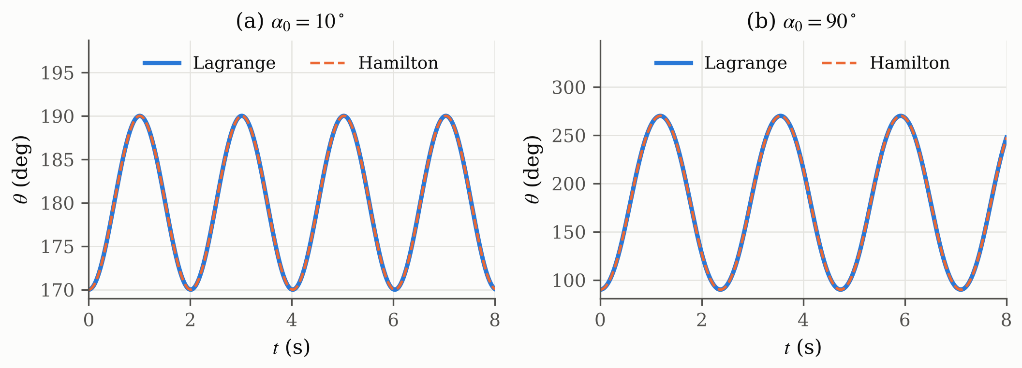
Figure 2.1. Planar swing (${\dot{φ}}_{0}=0$) started at (a) $α_{0}={10}^{∘}$ and (b) $α_{0}={90}^{∘}$, where the Lagrange (solid) and Hamilton (dashed) results lie on top of each other
For the planar swing the motion stays in one vertical plane and Equation (2.12) reduces to the simple pendulum. The angle $θ$ swings around ${180}^{∘}$ (the lowest point), and values above ${180}^{∘}$ mean that the bob has passed to the other side. The period of the program is 2.00989 s at ${10}^{∘}$, almost the small-angle value $2π\sqrt{l/g}=2.00607$ s, and 2.36784 s at ${90}^{∘}$, 18 % longer, because the small-angle formula of Equation (2.24) only holds for small swings. Both values equal the exact pendulum period. A link four times longer (0.5 m to 2 m) doubles the period (1.42121 s to 2.84242 s), as expected from $T∝\sqrt{l}$.
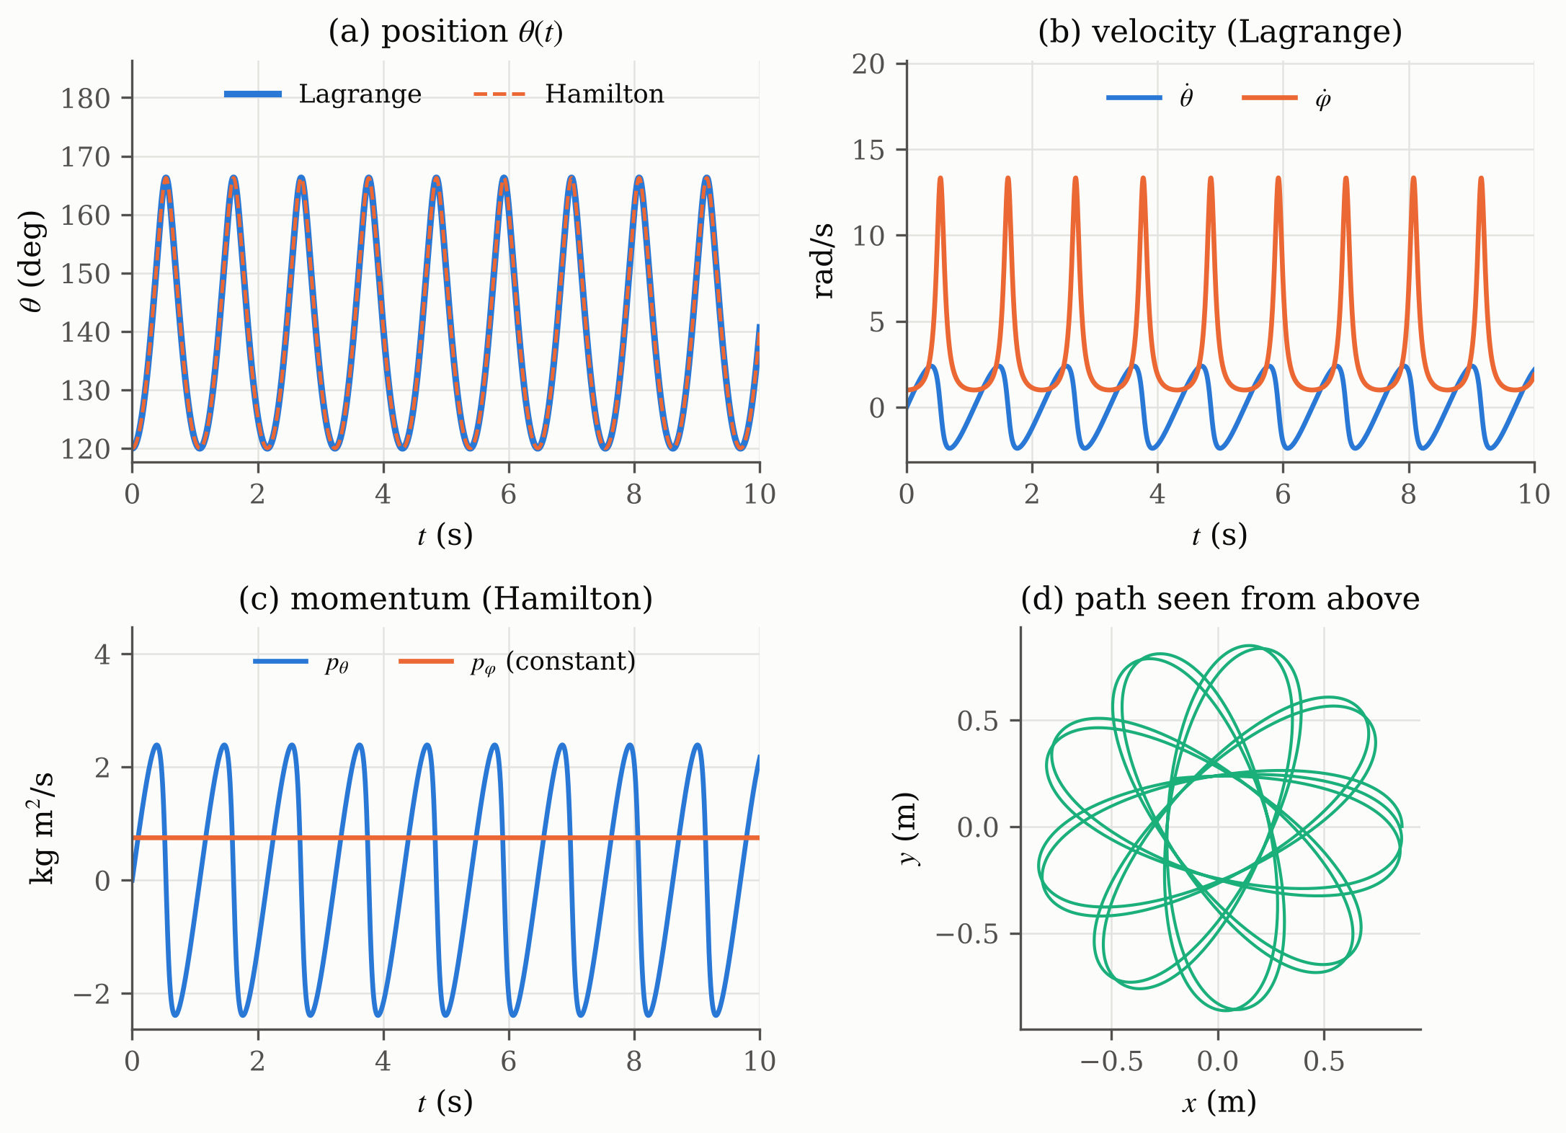
Figure 2.2. General motion ($α_{0}={60}^{∘}$, ${\dot{φ}}_{0}=1$ rad/s), shown in the four charts of the program, namely (a) position $θ$ from both methods, (b) velocity from the Lagrange method, (c) momentum from the Hamilton method, (d) path of the bob seen from above
In the general case the bob does not stay in a plane. It swings between $α={60}^{∘}$ and ${13.7}^{∘}$ while it turns around the vertical axis, so the path seen from above is a rosette, Figure 2.2(d). When the bob comes close to the axis, $\dot{φ}$ rises from 1 to about 13 rad/s, Figure 2.2(b), while $p_{φ}$ stays at 0.75 kg m²/s, Figure 2.2(c). This shows the practical difference between the two methods. The Lagrange velocity changes strongly, whereas the Hamilton momentum shows the conservation law directly. For the conical preset, started with the rate $Ω$ of Equation (2.24), $α$ stays at ${30}^{∘}$ and the bob moves on a circle. Table 2.1 collects the results.
Table 2.1. Program results compared with the expected values
Case | Result of the program | Expected
Planar, $α_{0}={10}^{∘}$ | period 2.00989 s | 2.00989 s (exact), 2.00607 s (small angle)
Planar, $α_{0}={90}^{∘}$ | period 2.36784 s | 2.36784 s (exact)
Length 0.5 m and 2 m | periods 1.42121 s and 2.84242 s | ratio 2
Conical, $α_{0}={30}^{∘}$ | $α$ constant, $Ω=3.3657$ rad/s | $α$ constant
General, $α_{0}={60}^{∘}$ | $α$ between 13.72° and 60° | 13.72° and 60° (energy equation)
Lagrange vs Hamilton | largest difference of $θ$ is $2.3×{10}^{-9}$ rad | 0
Energy $H$ and $p_{φ}$ | $H$ within $4×{10}^{-10} mgl$, $p_{φ}$ within $8×{10}^{-10}$ kg m²/s | constant

2.4 Evaluation and Discussion
The results agree with Chapter I. Problem 1 shows that Hamilton’s principle and the Lagrange equation are the same law, and that $∂L/∂\dot{θ}$ is the momentum and $\dot{p}=F$ is Newton’s law, in the linear form ($m$, $F=ma$) or in the rotational form ($I$, torque). The difference to the senior report is therefore not a different law but the inertia of the coordinate. The mass $m$ is correct for a distance, while an angle needs the moment of inertia.
For Problem 2 the Lagrangian method gives two second-order equations (position and velocity) and the Hamiltonian method four first-order equations (position and momentum), as stated in Table 1.1. The program confirms that both give the same motion, to $2.3×{10}^{-9}$ rad after 20 s, and that $H=T+V$ and $p_{φ}$ stay constant. The equations themselves give accelerations or rates, so the position always requires an integration in time, which here is done with RK4. One limitation is the vertical axis ($sinθ=0$), where $φ$ is undefined. The program therefore accepts start angles between 0° and 180° only. This matters for the Final Project, where the arm hangs on this axis at rest.

CHAPTER III. CONCLUSION

Hamilton’s principle $δ∫\left(T-V\right) dt=0$ and the Lagrange equation $\frac{d}{dt}∂L/∂\dot{θ}=∂L/∂θ$ were shown to be equivalent by varying the path with fixed end points and integrating by parts. With $T=1/2M{\dot{θ}}^{2}$, $∂L/∂\dot{θ}=M\dot{θ}=p$, and the Lagrange equation becomes $\dot{p}=F=-∂V/∂θ$, which is $F=m\ddot{x}$ for a distance and $τ=I\ddot{θ}$ for an angle.
For the pendulum of the assignment figure, with $r=l$ fixed, $T=1/2ml^{2}\left({\dot{θ}}^{2}+\sin^{2}θ {\dot{φ}}^{2}\right)$ and $V=mglcosθ$. The Lagrangian method gives $\ddot{θ}=sinθcosθ {\dot{φ}}^{2}+\left(g/l\right)sinθ$ and $\ddot{φ}=-2cotθ \dot{θ}\dot{φ}$. The Hamiltonian method gives $H=T+V$ and four first-order equations in $θ$, $φ$, $p_{θ}$ and $p_{φ}$, with $p_{φ}$ constant.
The Delphi program integrates both sets of equations with RK4 to obtain the position, velocity and momentum. Both methods give the same motion, the periods match the exact pendulum, and the energy and $p_{φ}$ remain constant.

REFERENCES

[1] A. Arifin, “Lagrangian and Hamiltonian mechanics,” lecture slides, Biocybernetics (EB234701), Dept. Biomed. Eng., Inst. Teknologi Sepuluh Nopember, Surabaya, Indonesia, 2026.
[2] H. Goldstein, C. Poole, and J. Safko, Classical Mechanics, 3rd ed. San Francisco, CA, USA: Addison-Wesley, 2002.
[3] T. W. B. Kibble and F. H. Berkshire, Classical Mechanics, 5th ed. London, U.K.: Imperial College Press, 2004.
[4] S. C. Chapra and R. P. Canale, Numerical Methods for Engineers, 7th ed. New York, NY, USA: McGraw-Hill Education, 2015.

